FRENCH OAK AND ELM CABINET, FRANCE, CIRCA 1945

EA4026

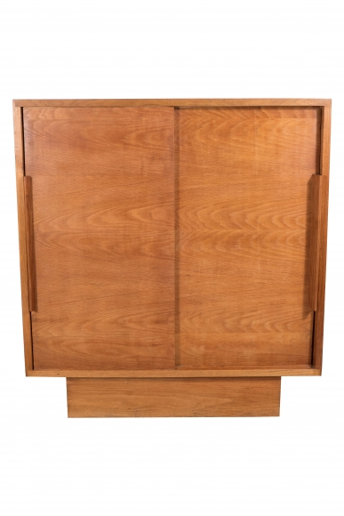

French oak and elm cabinet, France, circa 1945

