CARL MALMSTEN HIGH BACK SOFA

Sweden, circa 1960

EA3892

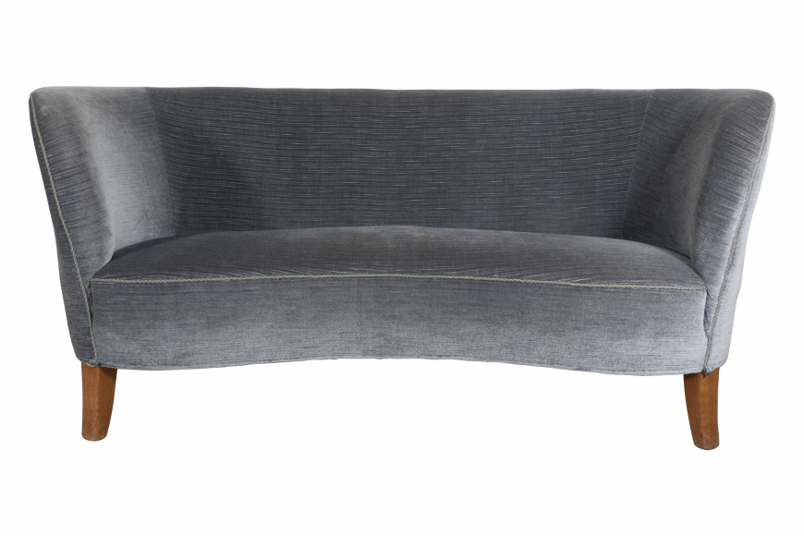

Wood, Upholstery
H: 29 W: 65.5 D: 28 in.

