COFFEE TABLE ATTRIBUTED TO DIRECTIONAL IN THE STYLE OF PAUL EVANS

USA, c. 1960

EA3831

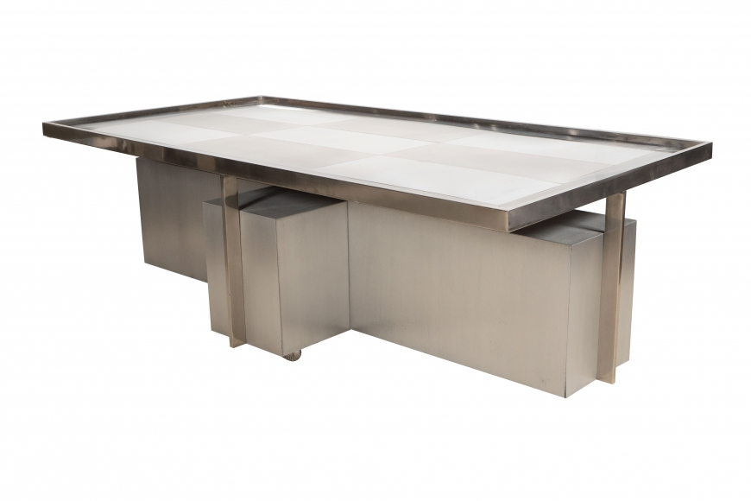

1960s Coffee Table Attributed to Directional in the Style of Paul Evans
H: 13.5 W: 47.75 D: 23 in.

