PAIR OF PIERO FORNASETTI CIRCULAR MIRRORS

Italy, c. 1950

EA2063

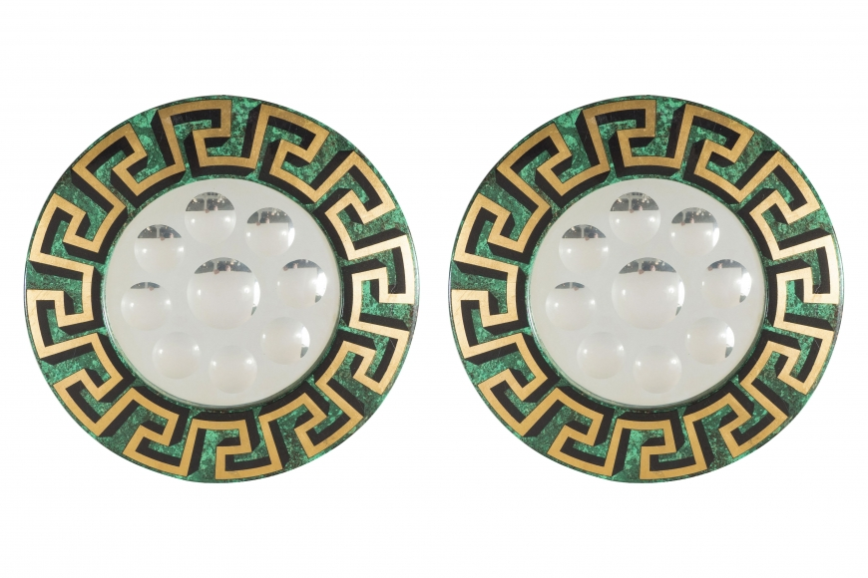

Each broad circular frame printed with a Greek key motif in black and gilt on a malachite ground, with a circular mirror cut with nine convex circles.
Diameter: 19”

