EDMUND SPENCE LONG CHEST WITH WAVE FRONT DRAWERS

Scandinavian, c. 1950

EA
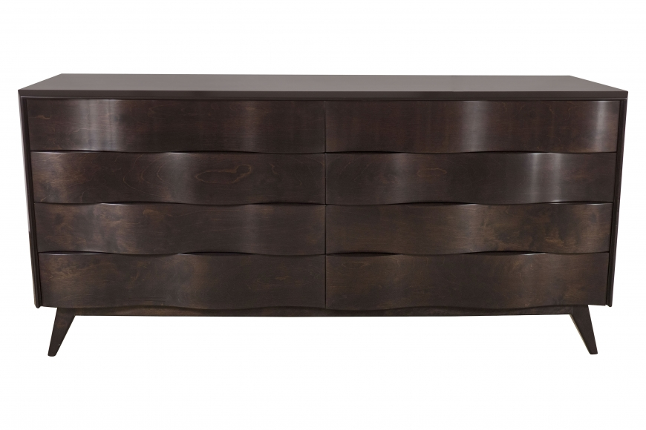

H: 31.25 D: 20 W: 66.25 in.

