A CURTIS JERE ROUND EYE LASH MIRROR

USA, c. 1970

EA2741
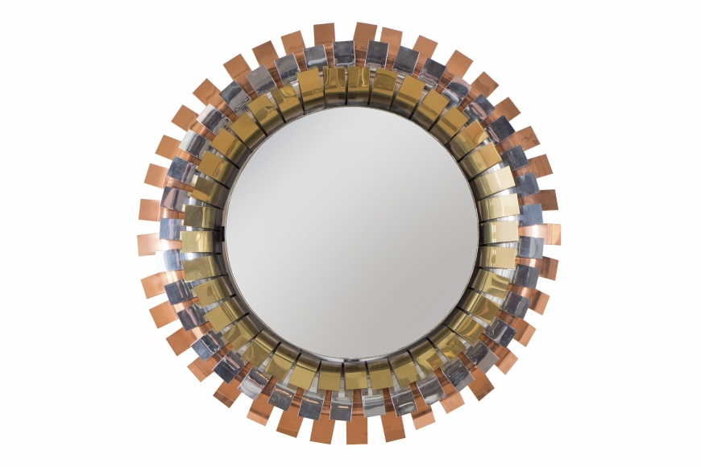
Circular frame formed of curved brass, chrome and copper sections, supporting a mirror in the centre
Diam. 20 in.

