PAIR OF WALL SCONCES, LIGHTOLIER, ATTRIBUTED TO GERALD THURSTON

USA, c. 1950

EA2824

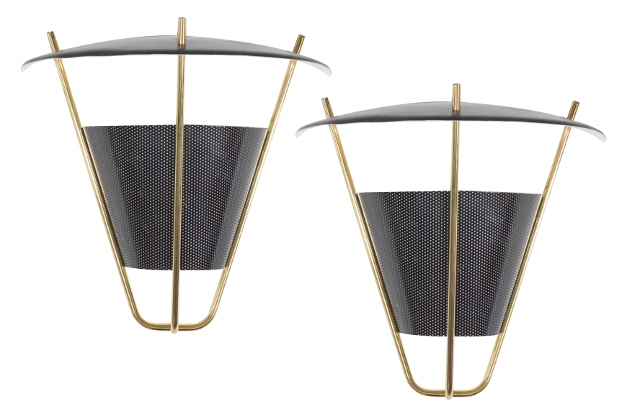

Metal and Brass
12” x 6.5” x 13” high

