EDWARD WORMLEY FOR DUNBAR THEBES STOOL

USA, c. 1950

EA3144

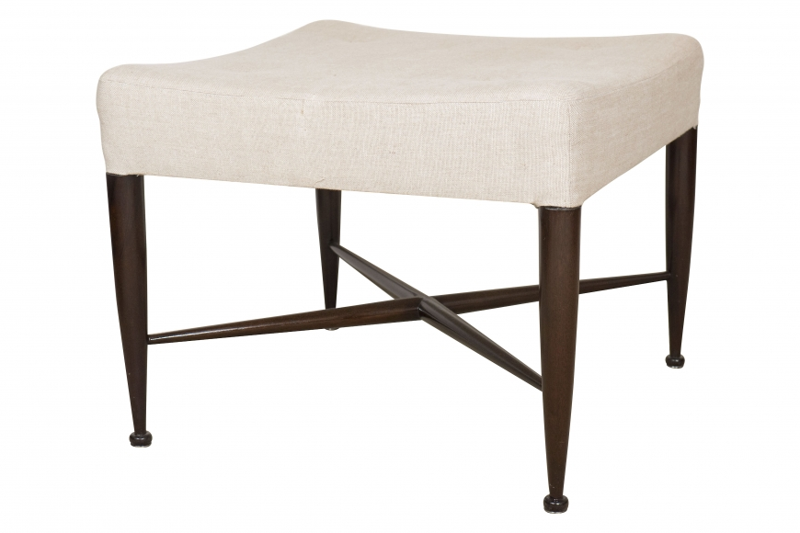
Upholstered square seat, raised on four slender tapering legs with a button foot and stretcher

H: 15.5 D: 22.5 W: 22.5 in.

