# MID-CENTURY CERAMIC TILE-TOP TABLE WITH BRONZE TRIPOD BASE, SIGNED, CIRCA 1950

## USA, c. 1950

### EA3781

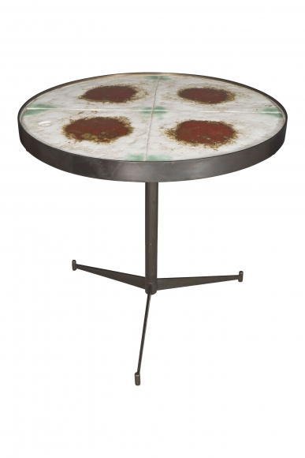

Bronze and Ceramic

H: 22 in. Diam: 23.5 in.