PAIR OF SAPORITI CHAIRS BY A. BOZZI IN ORIGINAL FENDI TEXTILE

Italy, c. 1960s
EA3873

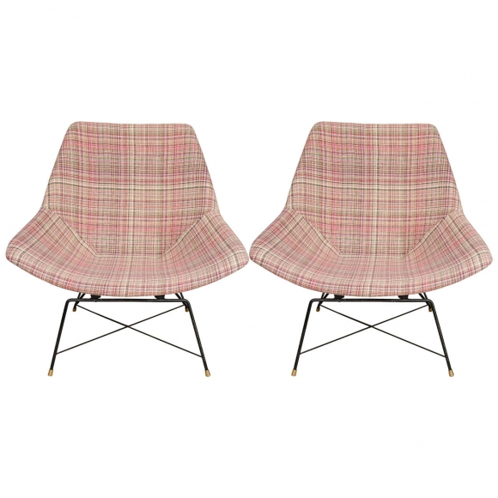
Steel and Textile
H: 34 W: 34 D: 24 in.

