PAUL EVANS BURLED WOOD AND CHROME MULTI-FACETED CABINET

USA, c. 1970

EA2895

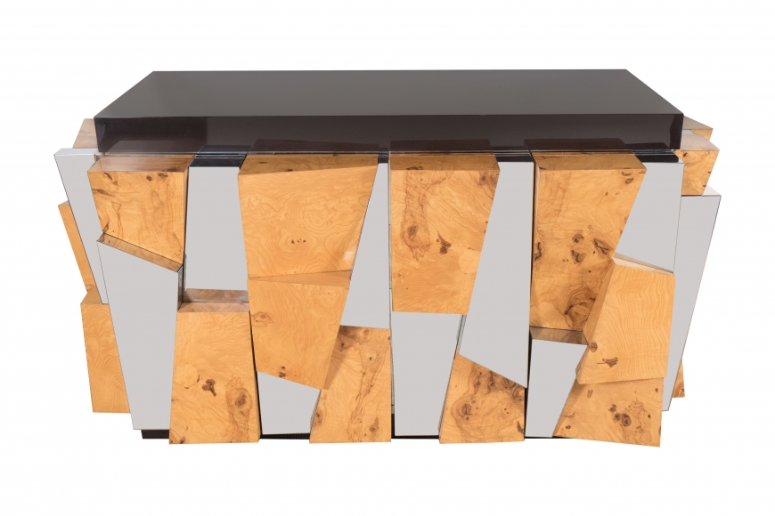

Cabinet with double hinged doors and high relief multiple angled panels veneered in chrome and burled wood by Paul Evan, USA c. 1970
Dimensions: W: 60” D: 25” H: 32.5”
Price: $45,000

