PAIR OF STILUX FLOOR LAMPS IN BLACK AND WHITE

Italy, c.1950

EA3869 & EA3870

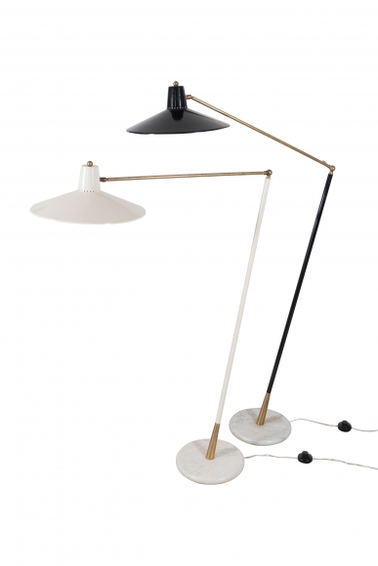
Tole, Brass, and Marble
H: 68 Diam: 15 in.

