ROMEO REGA PLEXIGLASS, CHROME, AND GLASS LARGE COFFEE TABLE

Italy, c. 1970's

EA3884

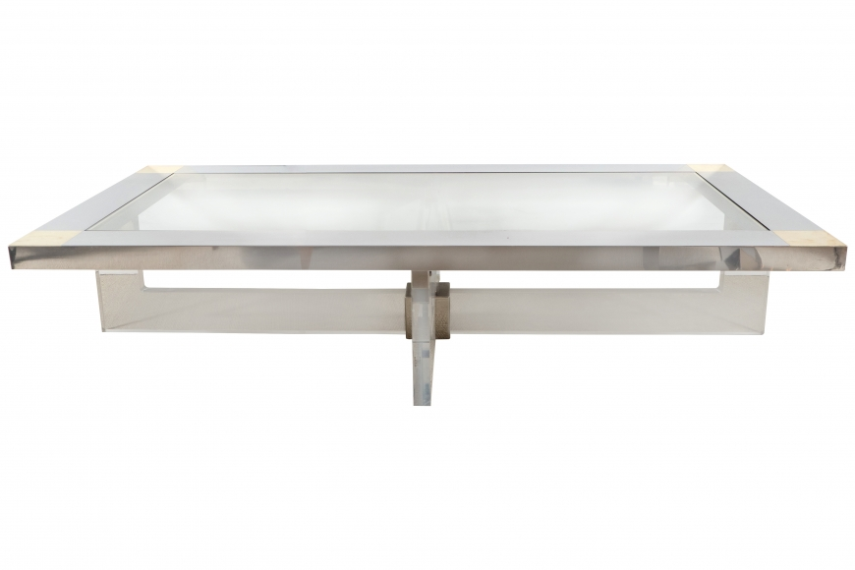

H: 17 W: 71 D: 35.5 in.

