TORTOISE PLEXIGLAS TRAY TABLE WITH A BRASS "X" BASE, ARCHEA-MILANO, 1970

France

EA3729

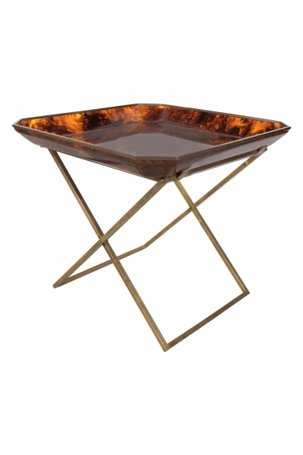
Designed by Monique Roger and Vincent Jacquard of 'Archea-Milano', 1970. Sold at select boutiques in the 70s: Christian Dior, Ave. Montaigne, David Hicks, Paris, and Khazen Gallery, Beirut.
H: 23.5 W: 25.75 D: 25.75 in.

