MAISON JANSEN MIRROR TORTOISE TOP AND GUNMETAL BASE COFFEE TABLE

France, c. 1940

EA3737

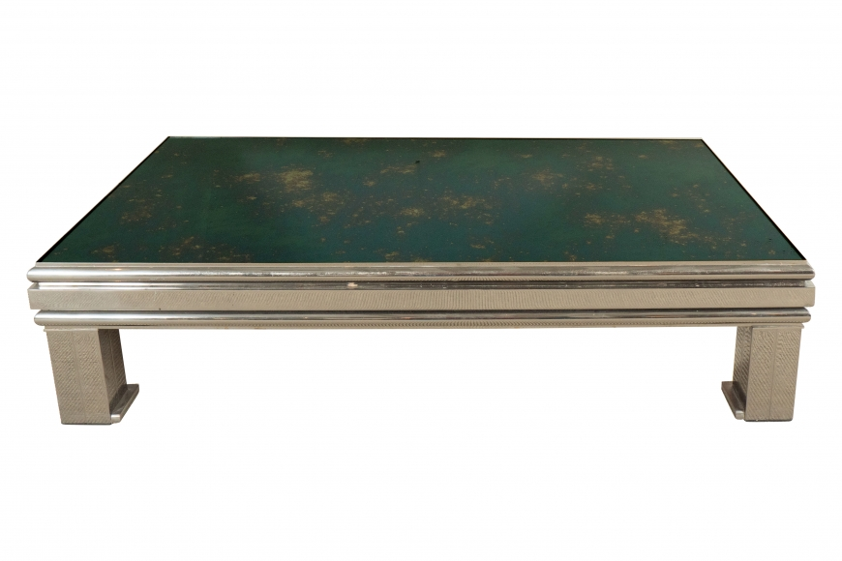

Dimensions: W: 47” D: 27.5” H: 12”

Price: $7,000

