LOW CIRCULAR GLASS AND CHROME SIDE TABLE

France, Contemporary

EA3413

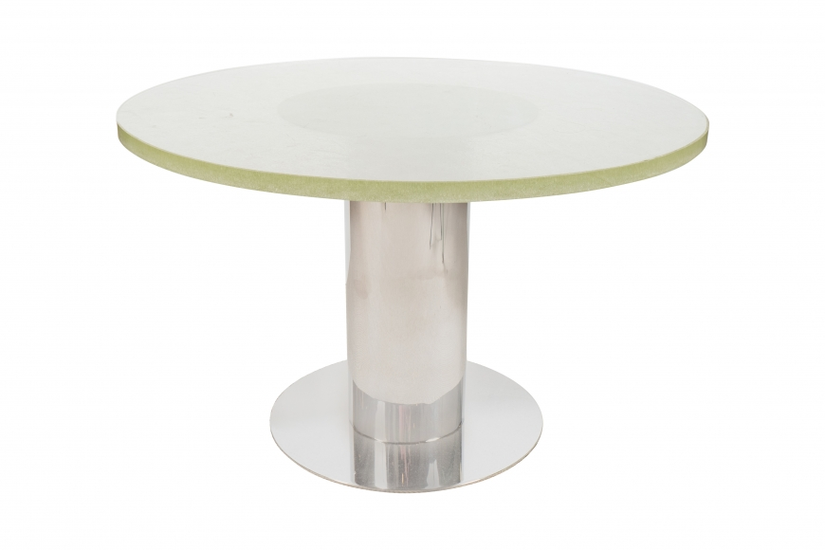

Contemporary cylindrical chrome base supporting a vintage Saint Gobain glass top, France
Dimensions: H: 16” Diam: 26.5”
Item# EA3413
Price: $10,000

