JEAN BESNARD CERAMIC LAMP WITH CORD MOTIF ON A FLAT VERTICALLY INCISED BASE

France, c. 1940

EA3617

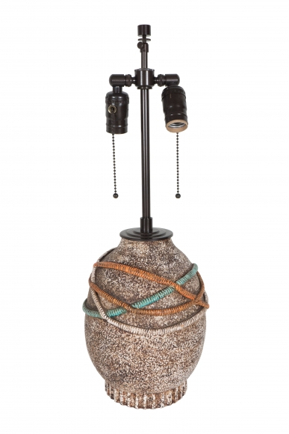

A Ceramic Lamp with Cord Motif Supported on a Flat Vertically Incised Base, Signed "Besnard", France
Dimensions: H: 22.5” Diam: 8”
Price: $5,625

