A LARGE OCTAGONAL LUCITE TABLE LAMP

USA, c. 1960

EA3369

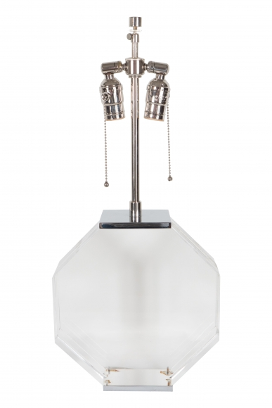

The octagonal formed Lucite disc table lamp in the manner of Karl Springer
Dimensions: W: 10” D: 4” H: 23.5” (adjustable harp)
Price: $4,800

