BROWN WHITE CERAMIC LAVA LAMP

USA, c. 1960's

EA3806

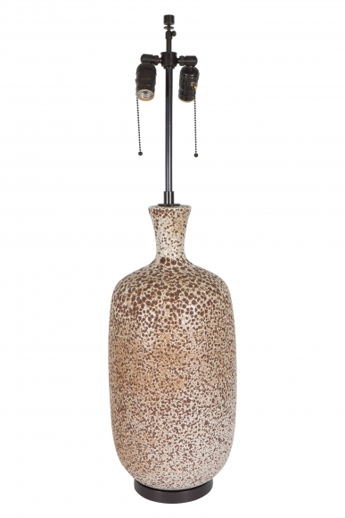

H: 34.5 Diam: 8.5 in.

