AN ED WORMLEY FOR DUNBAR TRAVERTINE AND WOOD SIDE TABLE

USA, c. 1950

EA3183

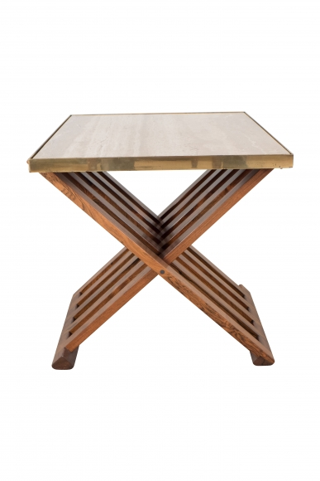

The travertine top into a brass frame, supported on an intertwined wooden slat base.
H: 21.25 W: 23 D: 25.5 in.

