GINO SARFATTI FOR LIGHTOLIER ENAMELED TRIPOD FLOOR LAMP

USA, c. 1950

EA3526

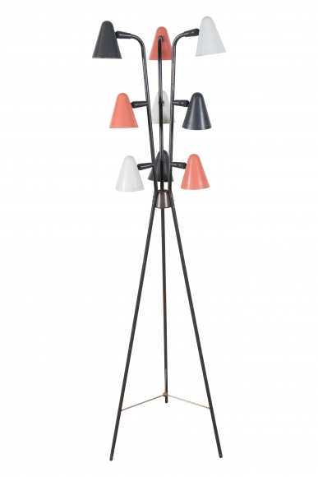
The black enameled tripod base supporting three sets of three colored enameled cone shaped shades.
H: 60 Diam: 16 in.

