JEAN BESNARD CERAMIC VASE

France, c. 1940

EA3877

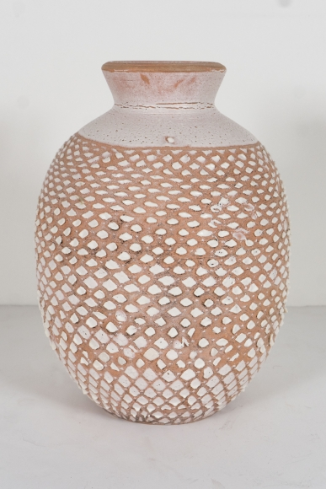

Important Jean Besnard Ceramic Vase, France, circa 1940, signed with initials on underside.
H: 8.5 Diam: 6.5 in.

