A WILLY RIZZO CHROME, BRASS AND SMOKED GLASS COFFEE TABLE

Italy, c. 1970

EA3406

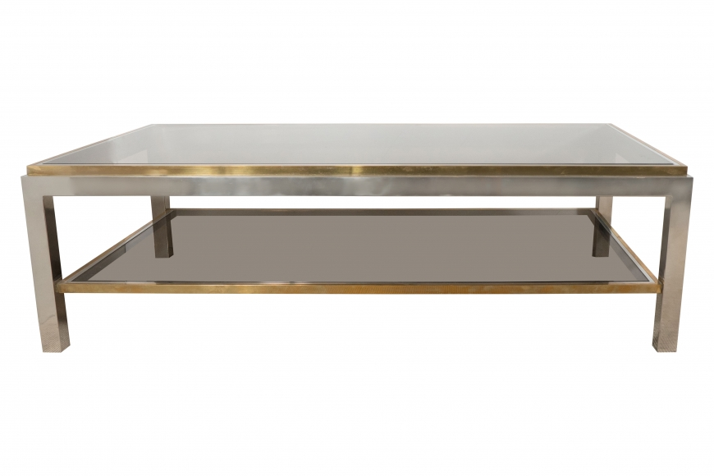

The rectangular two-tiered coffee table with stepped brass trim holding the smoked glass, raised on a chrome frame.
Dimensions: W: 51” D: 27.5” H: 16”
Price: $8,500

