RED CERAMIC VASE BY ROBERT AND JEAN CLOUTIER

France, c. 1970

EA3984

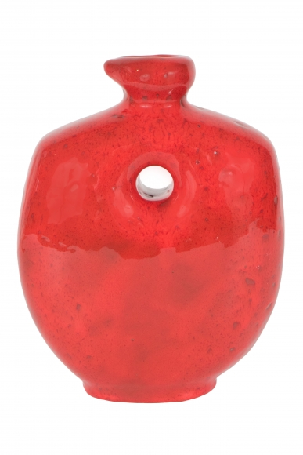

H: 8.5 W: 6 D: 6 in.

