TOLE OFF WHITE CHANDELIER WITH BRASS ROD AND FOUR ROUND ADJUSTABLE SHADES

Italy, Contemporary

EA3715

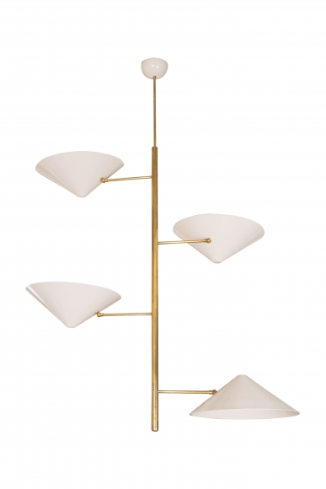

Tole off white chandelier with brass rods and four round dome adjustable shades, Italy, circa 2000.
H: 60 W: 40 D: 14 in.

