1950S STYLE OCCASIONAL TRIPOD TABLE, MADE TO ORDER

USA, Contemporary

EA3361

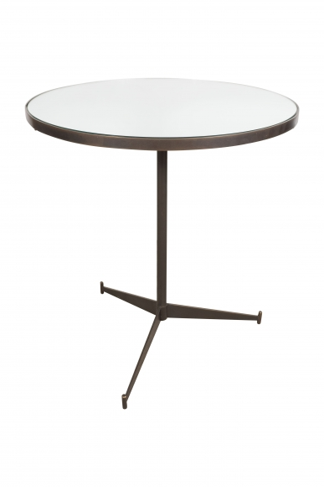

Bronze bass with mirrored top.
H: 22.25 Diam: 20.25 in.

