A LARGE BRASS MULTI-ARM CHANDELIER

West Germany, c. 1950's

EA2651

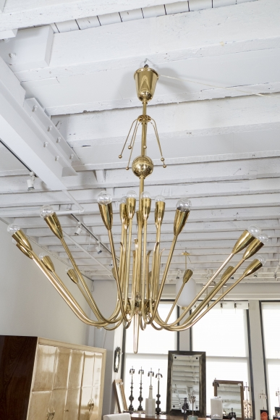

Applied with U shaped arms, lit at both ends, on a rod and ball stem.
H: 58 Diam: 48 in.

