ITALIAN MODERNIST 1950S BRASS FRAMED MIRROR

Italy, c. 1950's

EA3610

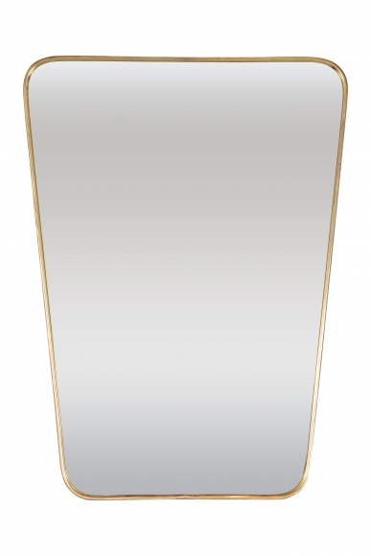

H: 28 W: 20.5 in.

