PAIR OF AUGUSTO BOZZI SAPORITI CHAIRS

Italy, c. 1960's

EA3808

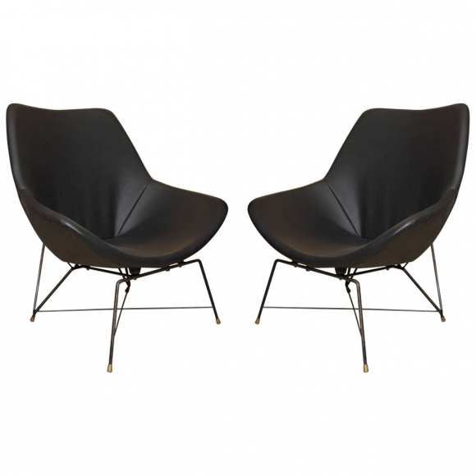

H: 34 W: 34 D: 24 in.

