CHROME MIRROR AND BRASS CONSOLE TABLE

France, c. 1970's

EA3824

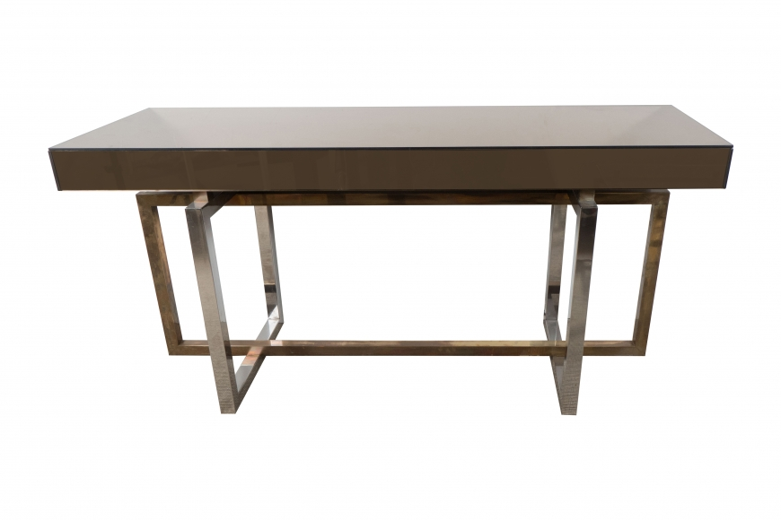

Dimensions: H: 29.5” W: 59” D: 19.5”

Price: $15,000

