KERAMOS CERAMIC FRENCH TABLE LAMP BY ROBERT MATHIEU

France, c. 1940

EA3918

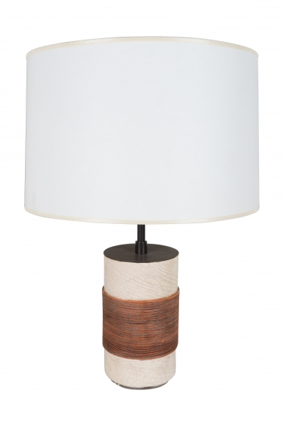
H: 20.75 Diam: 5 in.

