LIMITED EDITION CONSTRUCTIVIST INSPIRED CUSTOM-MADE TABLE BY ERIC APPEL

USA, Contemporary

EA3942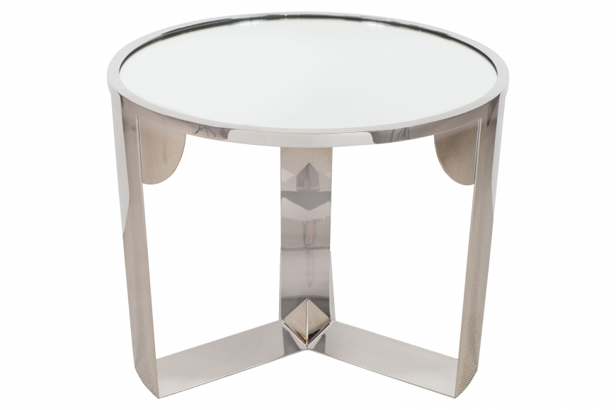

Limited edition constructivist inspired custom-made table by Eric Appel, USA.
Mirror top and polished stainless nickel finish base with pyramid design.
Dimensions: H: 21” Diam: 25.5”
Price: $12,000

