PETRIFIED WOOD AND MIRROR POLISHED BRONZE OCCASIONAL TABLE

USA, Contemporary

EA3972

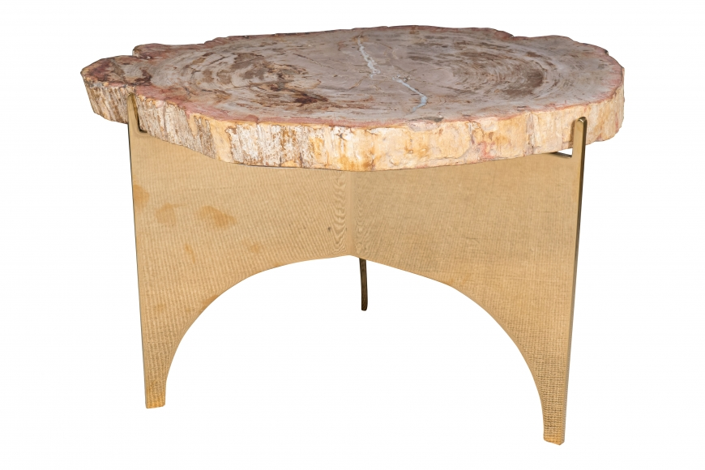

A petrified wood and mirror polished bronze occasional table designed by Eric Appel.
H: 18 Diam: 15.5 in.

