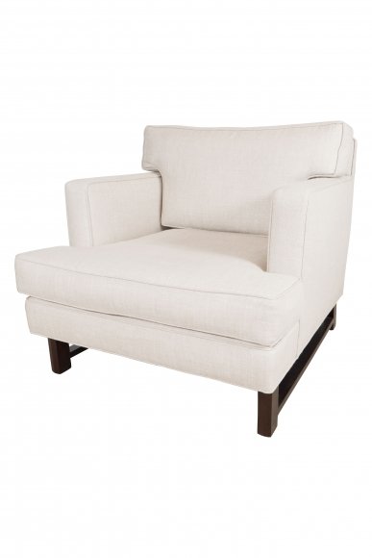

Mid-Century style club chair in the manner of Ed Wormley, Contemporary

W: 31” D: 33” H: 29” Seat: 16” Arm: 23”

Item#: EA3182

Price: $5,500

