A PAIR OF CURVED BACKED UPHOLSTERED CHAIRS, 1960S STYLE, WITH BRONZE LEGS

USA, Contemporary

EA3642

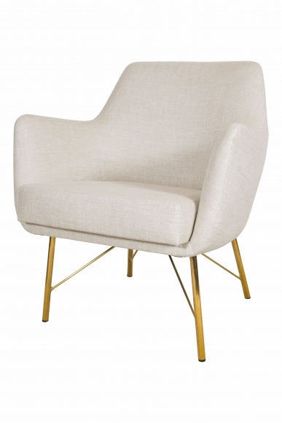

H: 28 W: 26 D: 26 in.

