ADNET TABLE MIRROR WITH LIGHT

France, c. 1950

EA3838

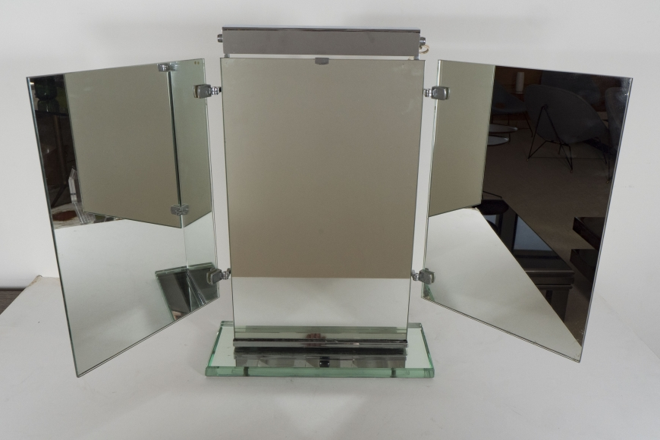

Adnet table mirror with light, France, c. 1950
H: 22 W: 32 D: 6 in.

