FRENCH BRASS AND PLEXIGLASS TABLE LAMP

France, c. 1970

EA3903

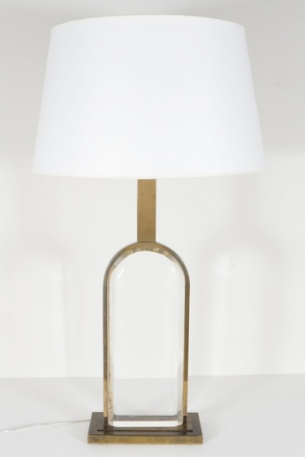

H: 34.5 W: 9.75 D: 4.25 in.

