BRASS AND CRYSTAL GEODE SCULPTURE BY SERGIO FOR CAROLE STUPELL

USA, c. 1960's

EA3651

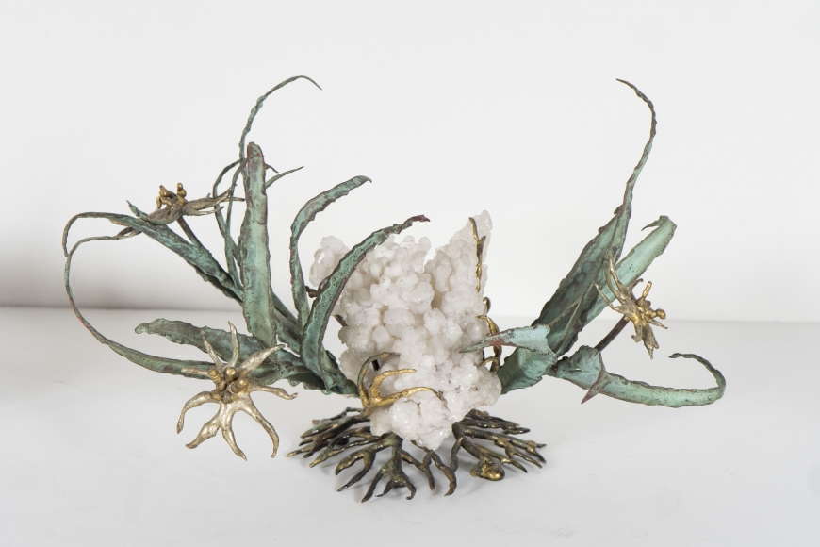

H: 7.5 L: 12 D: 8 in.

