LEE ROSEN STUDIO LAMP FOR DESIGN TECHNICS (STAMPED)

USA, c. 1970's

EA4067
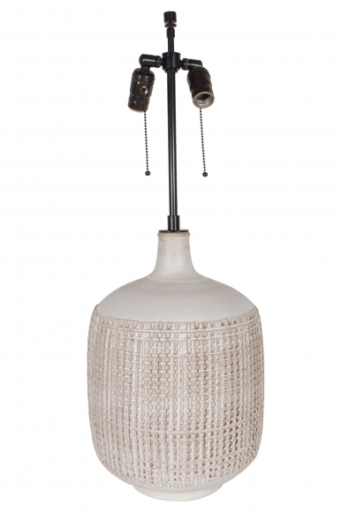
Ceramic
H: 29.5 Diam: 10 in.

