UPRIGHT RECTANGULAR CERAMIC LAMP WITH BRONZE BASE IN THE STYLE OF TOMMI PARZINGER

USA, c. 1950

EA3962

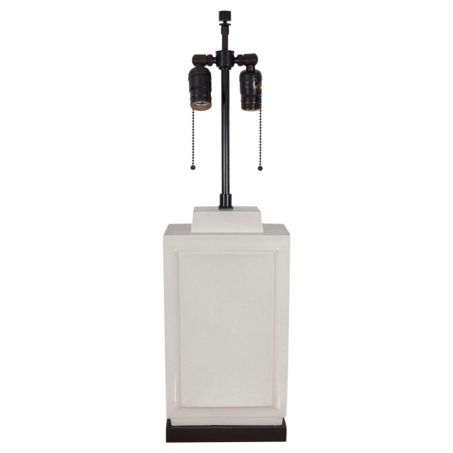
H: 26.5 W: 7.5 D: 4 in.

