ITALIAN WHITE CERAMIC TREE BASE LAMP

Italy, c. 1960's

EA3720B

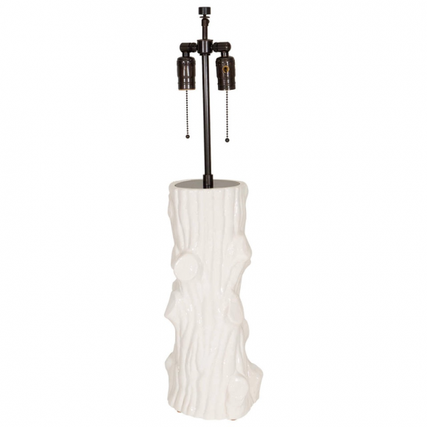
By Giovanni Patrini
H: 30 Diam: 7 in.

