JEAN GRISONI 'PIETRA' STEEL RING VASE

France, Contemporary

c. 2016

BR 007B

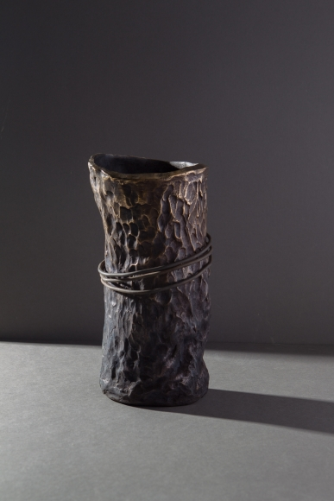

Jean Grisoni 'Pietra' steel ring vase.
H: 10.5 Diam: 5.25 in.

