JEAN GRISONI PAIR OF BRONZE 'NONZA' AND SINGLE 'OLMETA' CANDLE HOLDERS

France, Contemporary

c. 2016

BR 002,003,006

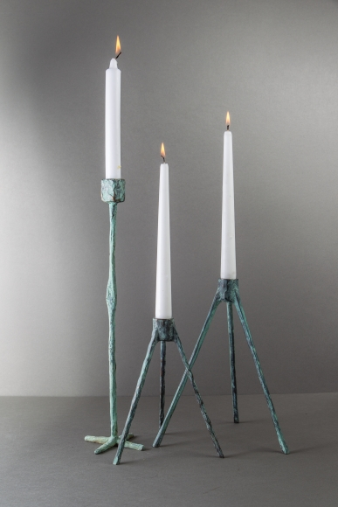
Jean Grisoni pair of bronze 'Nonza' and Single 'Olmeta' candle holders
BR 002- Medium 'Nonza' candle holder- H: 10 Diam: 1.5 in.
BR 003- Small 'Nonza' candle holder- H: 8 Diam: 1.25 in.
BR 006- 'Olmeta' candle holder- H: 15.75 Diam: 1.25 in.

