BLACK & GOLD DECO LAMP, BOULOGNE

France, c. 1930's

EA4090
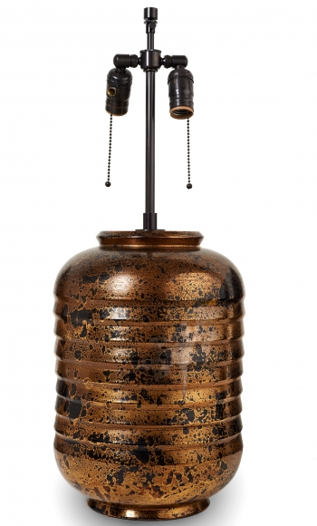

H: 14.5 Diam: 9.5 in.

