CERAMIC GRAY & ORANGE LAMP BY JULIETTE DEREL AND JEAN RIVIER

France, c. 1960

EA4093
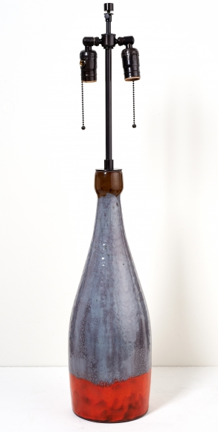

H: 32 Diam: 6.5 in.

