GMCE BLACK LONG LIGHT FIXTURE

Italy, c. 1960

EA4041A

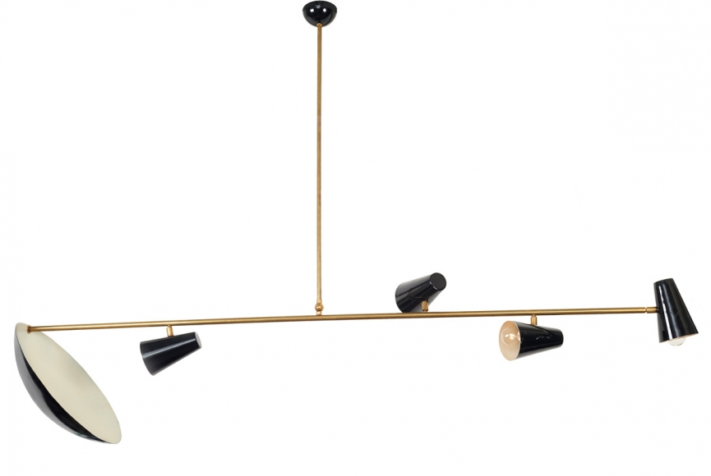

H: 52 W: 72 D: 17 in.

