AMERICAN CERAMIC PLAID LAMP

USA, c. 1940's

EA4130

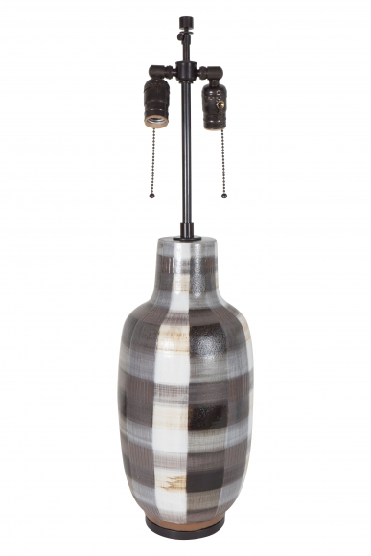

H: 29 Diam: 7 in.

