THONET BLACK LACQUER STOOL/TABLE

USA, c. 1950's

EA4131

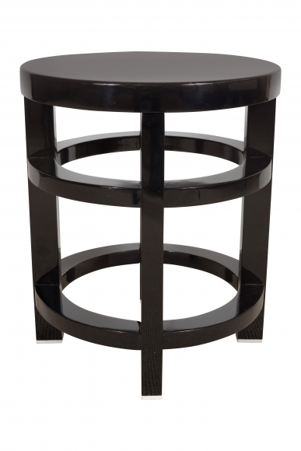

H: 14.25 Diam: 13.25 in.

