SWEDISH ROSTRAND BLACK CERAMIC BOWL, SIGNED

Sweden, c. 1950's

EA4070

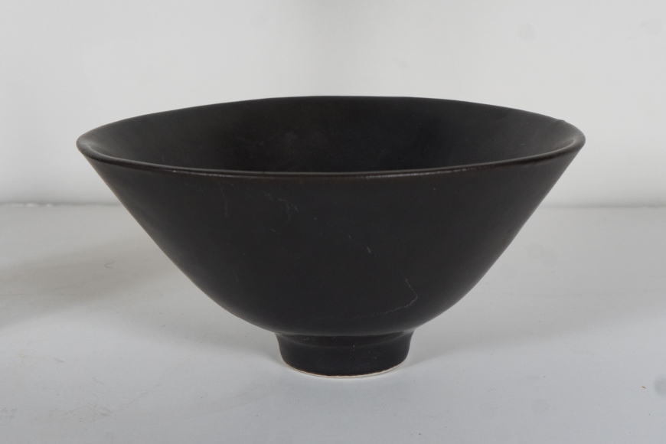

H: 2.75 Diam: 5.75 in.

