SQUARE MOLDED CERAMIC TABLE LAMP

USA, c. 1950's

EA3358
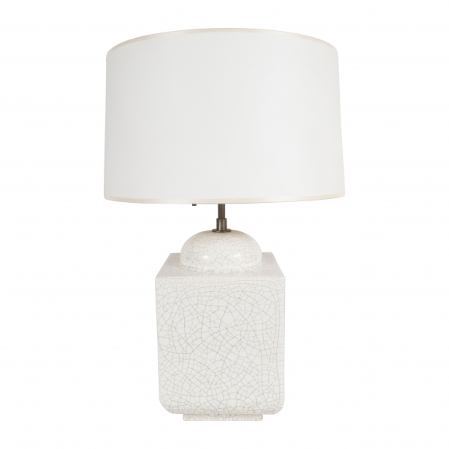

A square molded ceramic Table lamp, with a cream crackle glaze.
H: 24 Diam: 8.25 in.

